|  |  |  |  |  |  |  |  |  |  |  |  |  |  |
| --- | --- | --- | --- | --- | --- | --- | --- | --- | --- | --- | --- | --- | --- |
|  | | **PLAN 　 RECORD** | | | | REVISIONS | | | | AP- | CHECK- |  | |
| DRAWING NO.  GZ10-E2470 | | **ISO METRIC SCREW THREADS** | | | | NO. | DESCRIPTION(DATE) | | | PROVED | ED |  | |
|  | |  | | | |  | | | | | | | |
|  | | | | | | | | | | | |
| 係ｺｰﾄﾞ  RT0 | |  | | | | | | | | | | | |
|  | 5 SHEET(S) WITH COVER | | | | | | | | | | | |
|  |  | | MARINE MACHINERY  EQUIPMENT DESIGNING SECTION | | | | |  | | | | |
| ELECTRO-HYDRAULIC STEERING GEAR  PRE-INSPETION CHECK SHEET  FOR SFC TYPE STEERING GEAR |  | | **APPROVED**S. Dobashi | | | | |  | | | | |
|  |  | |  |  | | | |  | | | | |
|  |  | | **CHECKED** | S. Dobashi | | | |  | | | | |
|  |  | | **DRAWN** | R. Bamba | | | |  | | | | |
|  | **CONFERRED** | | **SCALE** |  | | | |  | | | | |
|  |  |  | **ORDER** | | | | **ITEM** | **DRAWING NO.** | | | | **REV. NO.** |
|  |  |  |  | | | |  | GZ10-E2470 | | | |  |
|  |  |  | **MITSUBISHI HEAVY INDUSTRIES**  **MARINE MACHINERY & EQUIPMENT CO., LTD.**  **MARINE MACHINERY DIVISION** | | | | | | | | | |

　　　　　　　　　　　　　　　　　　　　　　　　　　　　　　　　　 　 DRAWN 2018, 1. 22 ISSUED

Contents of pre-inspection (SFC type)

（1） Measuring mechnical clearances

1） Clearance between Ram pin and Ram pin bush

2） Clearance between Ram pin bush and Tiller

3） Clearance between Ram pin bush and Top plate

4） Clearance between Guide bar and Guide bar bearing bush

（2） Visual inspection

1） Indicater of Filter

2） Oil leakage from Hydraulic pump, Valve block and Pipe

3） Oil leakage from Hydraulic cylinder

4） Scratch on Ram

5） Condition of Pressure gauge

6） Wear condition of chain coupling

7） Plays of linkage mechanism for feed back unit and rudder angle transmitter

（3） Operation test

1） Rudder turning speed

2） Max working pressure

3） Abnormal noise

4） Safety valve test

（1）Measuring mechnical clearances

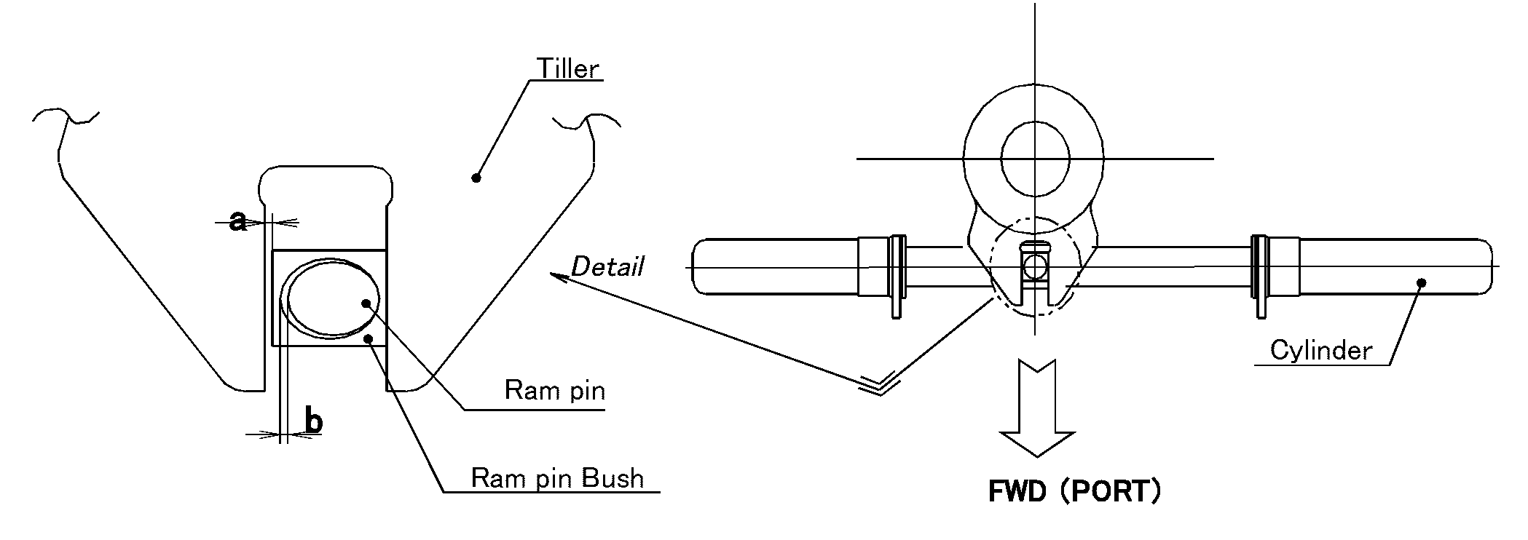

1) 2) Clearance around Ram pin bush 　　　　　　　　　　　　　　　　　　　　　　　　　　　　　　（mm）

|  |  |  |
| --- | --- | --- |
|  | Tiller and Ram pin bush　（a） | Ram pin and Ram pin bush　（b） |
| Upper limit | 0.5 | 0.5 |
| Upper side | mm | mm |
| Lower side | mm | mm |
| Judgement |  |  |

c

d

c

Detail

d

3）Crearance between Ram pin bush and Top plate　　　　　　　　　　　　　　　　　　　　　　　　　　　　（mm）

|  |  |
| --- | --- |
|  | Ram pin and Top plate (c) |
| Lower limit | 0.3mm |
| Clearance (c) | mm |
| Judgement |  |

4）Clearance between Guide bar and Guide bar bearing bush 　　　　　　　　　　　　　　　　　　　　（mm）

|  |  |
| --- | --- |
|  | Guide bar and Guide bar bearing bush (d) |
| Upper limit | 1.0mm |
| Clearance (d) | mm |
| Judgement |  |

（2） Visual inspection

1） Color of indicator for Filter

|  |  |  |
| --- | --- | --- |
|  | Color of indicator | Judgement |
| No.1 system | Green　　　・　　　Red |  |
| No.2 system | Green　　　・　　　Red |  |

2） Oil leakage from Hydraulic pump, Valve block and Pipe

|  |  |  |  |  |
| --- | --- | --- | --- | --- |
|  | Hydraulic pump | Valve block | Pipe | Judgement |
| No.1 system |  |  |  |  |
| No.2 system |  |  |  |  |

3） Oil leakage from Hydraulic cylinder

|  |  |  |  |
| --- | --- | --- | --- |
|  | Amount of oil leakage | Clearance of packing grand | Judgement |
| Criteria | 2 drops/min | Ｎtype：Min 3mm  F type：Min 5mm |
| No.1 cylinder | drops/min | mm |  |
| No.2 cylinder | drops/min | mm |  |

4) Scratch on Ram surface

|  |  |  |
| --- | --- | --- |
|  | Condition | Judgement |
| Ram surface |  |  |

5) Condition of Pressure gauge

|  |  |  |  |
| --- | --- | --- | --- |
|  | No | Condition | Judgement |
| Main pressure gauge | No.1 |  |  |
| No.2 |  |  |

6) Wear condition of chain coupling

|  |  |  |
| --- | --- | --- |
|  | Condition | Judgement |
| No.1 pump |  |  |
| No.2 pump |  |  |

7) Plays of linkage mechanism for feed back unit and rudder angle transmitter

|  |  |  |
| --- | --- | --- |
|  | Condition | Judgement |
| Feedback unit |  |  |
| Rudder angle transmitter |  |  |

（3）　Operation test

starboard 35゜

starboard 30゜

midship

port 30゜

port 35゜

|  |  |  |  |  |  |  |  |  |  |  |  |  |  |
| --- | --- | --- | --- | --- | --- | --- | --- | --- | --- | --- | --- | --- | --- |
|  |  | |  |  | |  |  | |  |  |  | |  |
|  |  | |  |  | |  |  |  | |  | |  |  |
|  | |  |  |  | |  |  |  | |  | |  |  |
|  | |  |  |  |  | |  |  | |  | |  |  |
|  | |  |  |  |  | |  |  | |  | |  |  |

　 　　 　 　 　 ① 　　②

1)2) Rudder turning speed (Criterion; 65deg within 28sec by one or two pumps operation）

|  |  |  |  |  |
| --- | --- | --- | --- | --- |
|  | STBD => PORT | | PORT => STBD | |
| Time | Max. Pressure | Time | Max. Pressure |
| No.1 Pump | sec | MPa | sec | MPa |
| No.2 Pump | sec | MPa | sec | MPa |
| Both Pumps | sec | MPa | sec | MPa |

　　 　 3) Abnormal noise (Criterion; no abnormal noise)

|  |  |  |
| --- | --- | --- |
|  | Abnormal noise | Place of noise |
| No.1 system |  |  |
| No.2 system |  |  |

4) Safety valve test (Design setting pressure; 27.0MPa or 22.0MPs)

|  |  |  |  |
| --- | --- | --- | --- |
|  | PORT | STBD | Judgement |
| No.1 pump | MPa | MPa |  |
| No.2 pump | MPa | MPa |  |